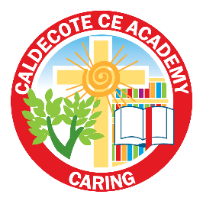
Early Years long term curriculum overview 2023 2024
Whole school project | EYFS project within whole school project
Autumn 1  Humans and Other Animals | Me and My Community  This project supports children with settling into the new rules and routines of school and encourages them to make new friends and feel confident in their class. It teaches children about being helpful, kind and thoughtful at home and at school. This project also teaches children how they are unique and special, the importance of friendship and how people in their family, school and local community are important and can help them. | Animal Safari  This project teaches children about the animals that live around the world, how to look after animals and the importance of caring for our local and global environments.
Autumn 2  Humans and other animals | Animal Safari continued  This project teaches children about the animals that live around the world, how to look after animals and the importance of caring for our local and global environments. | Exploring Autumn  This project teaches children about the natural changes that happen during the season of autumn, including how the weather changes, why trees lose their leaves and how wild animals prepare for winter.
Spring 1  Explorers | Puddles and Rainbows  This mini project teaches children about the weather that happens during spring and allows them to explore natural phenomena, including rainbows. It supports them to explore colour in the natural world. | Ready Steady Grow  This project teaches children about food and farming and explores themes, including where food comes from, what plants and animals need to grow and survive and what constitutes a healthy lifestyle.
Spring 2  Explorers | Let’s Explore  This project teaches children about the environments that they share with others, including their homes, school and places in the local community | Big Wide World  This project teaches children about the global community to which they belong and explores how living things, communities and climates differ around the world.
Summer 1  Through the Ages | Long ago  This project teaches children about how they have grown and changed since they were babies and how life in the past was different from today. | Starry Night  This project explores the differences in the world at night compared to during the day. It teaches children about the importance of a good night’s sleep, and helps them to discover what is happening in the world while they are sleeping, including finding out about nocturnal animals.
Summer 2  Through the Ages | Dangerous Dinosaurs  This exciting project teaches children about the different animals that roamed Earth millions of years ago and how they are related to animals that live on Earth today. | Moving on  This project celebrates the children’s successes throughout their Reception year. It explores how they have grown and changed and supports them with the changes to come as they move into Year 1.

