Online Safe Space

Central Bedfordshire Council (CBC) has added an Online Safe Space link to every one of its website pages.
If anyone is looking for information about where to get support if they are experiencing domestic abuse, they can click onto the blue, circular logo, which is found on the right hand side of the bottom of each page of the website. One click will take the user to a portal where they can access information. The portal is a secure, safe and untraceable and will not show in their internet browsing history and has a quick exit function too.
Visit the Central Bedfordshire Council’s website to try it https://www.centralbedfordshire.gov.uk/
We have shared the Online Safe Space on our social media and would encourage you to share Bedfordshire Domestic Abuse Partnership’s (BDAP) posts and tweets so that anyone following you can access support discreetly.

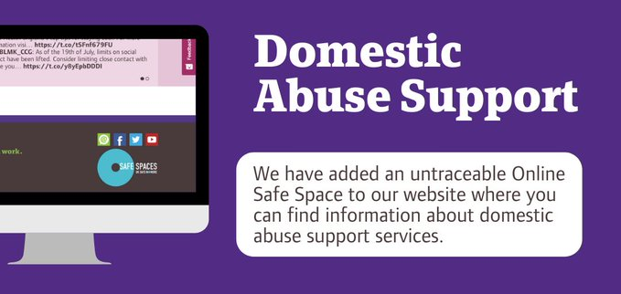

Contact us




Email: BDAP@centralbedfordshire.gov.uk
Website: www.bedsdv.org.uk
Facebook: www.facebook.com/bedsdv
Twitter: www.twitter.com/bedsdv

